How The Reverse Crease Method Has Helped To Establish Tech-ni-fold As The World Leader In Creasing Technology

Before the Tri-creaser was developed no single person or company had ever succeeded in preventing cracking from occurring on a folding machine. It took an experienced folding machine veteran of almost 20 years to identify the reasons why there hadn’t been such a breakthrough
After studying the methods of conventional Letterpress creasing on the converted Heidelberg Cylinder next to his folding machine, Graham Harris identified two simple facts:
1) No matter how hard and deep the crease was applied it would almost always crack open if folded the wrong way
2) One crease width and depth was never going to be good enough for all stocks that passed through the creasing Cylinder
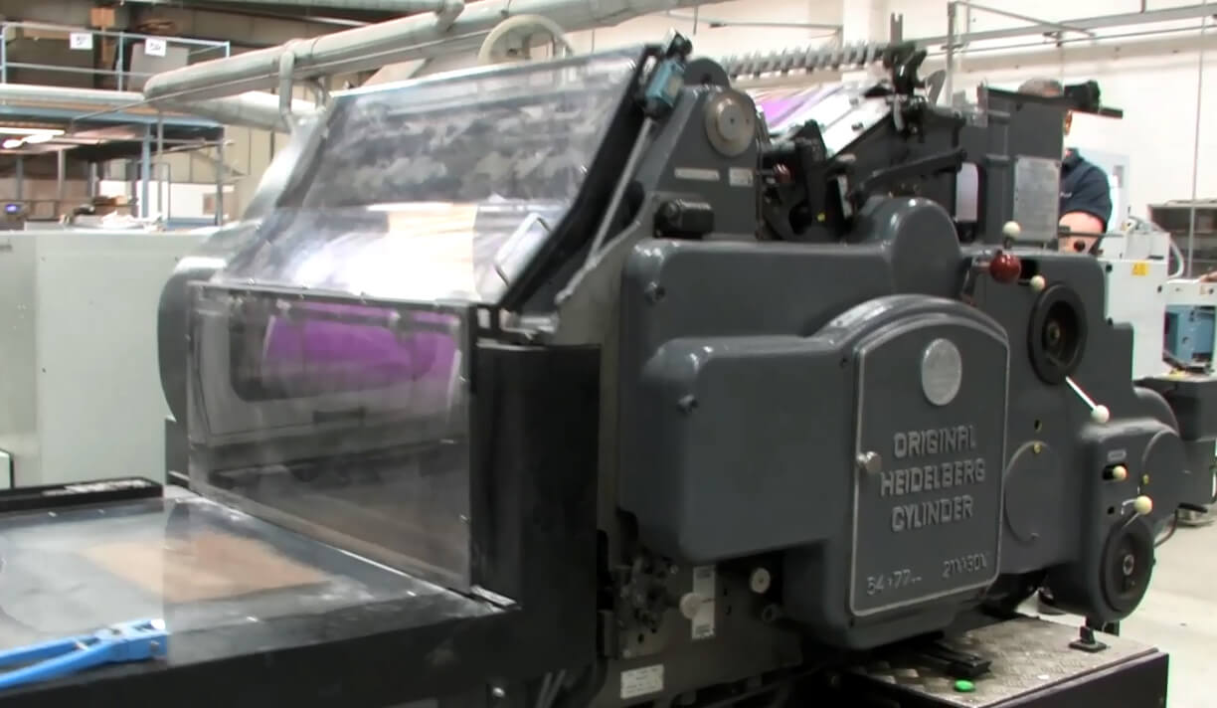
An Original Heidelberg Cylinder, in the past considered by many as the only acceptable method of creasing
Graham then turned his attention to his folding machine and methodically tested five of the leading scoring devices that he sourced from all over the world, and found three common failings:
1) Each device relied on a destructive circular steel profile that damaged most stocks
2) All systems produced a V-shaped score instead of the proven rounded profile produced on the creasing Cylinder
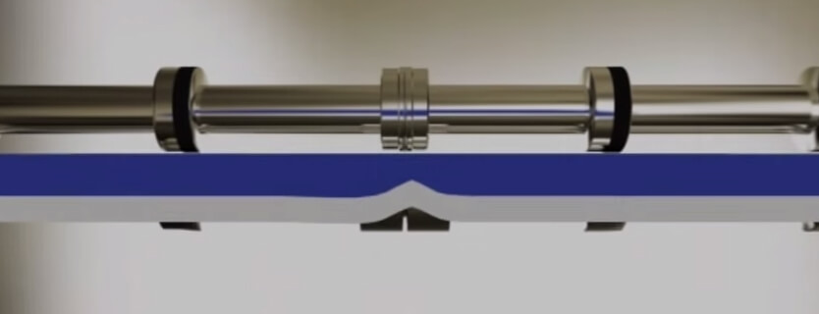An example of a v-shaped groove produced by traditional rotary metal scores
3) There was a lack of settings available (no more than two)
Graham simply introduced a specially formulated rubber creasing rib to replace the steel method and worked out several crease permutations that suited a wide range of printed materials that ran through his folding machine. Finally Graham adopted the reverse crease principal that made the Cylinder method so successful. In other words he didn’t crease inside the product before it was folded but on top (so that the bulge or bead was visible on the inside after folding). The results of each creasing impression matched the results he had seen on the Heidelberg Cylinder.
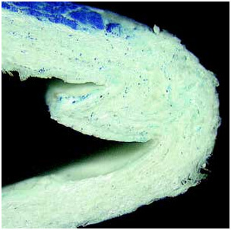
A close up shot of an inside bead, indicating a perfect crease
To see the Tri-Creaser Fast Fit in action and get a much better understanding of how this revolutionary device works, why not watch our latest video:
